- Create the GEC and FEC with CP and EP flow
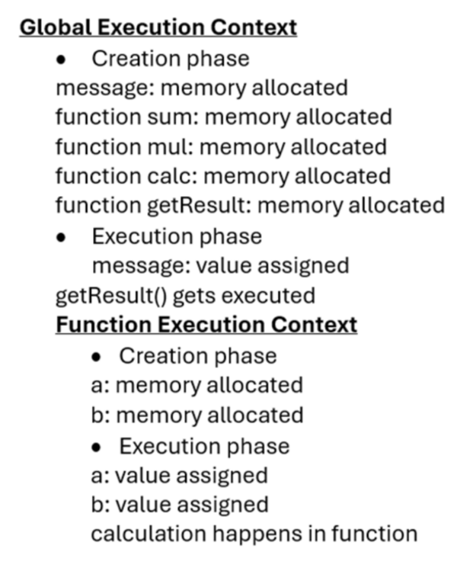
- Create the Stack and Heap flow
